

Faculty of Arts, Humanities. Education and Social Sciences
Cambridge School of the Creative Industries

MOD008624
Major Project for Games

Component 010-2
Development Report

SID: 2202692

Academic Year 2024/25

External Sources
My external sources are cited properly and listed in the References section, using CTR Harvard Referencing.

External Assets, Code and Tools
External assets/code/tools used in the artefact are acknowledged in the External Resources section. All the external assets/code/tools are properly licensed.

Tutorials
Tutorials and guides followed are acknowledged in the External Resources section.

AI Tools
I have used no AI tools in the creation of the report or the artefact.

Contents
External Sources 2
External Assets, Code and Tools 2
Tutorials 2
AI Tools 2
Contents 1
Table of Figures 2
Introduction 3
Investigation Aims 3
The Artefact 3
Background and Context 4
Subnautica 4
Horror in Design 5
Dread in Other Mediums 5
My Project Impact 6
Approach 7
The Gameplay 7
The Player 9
The Level 9
Artefact Outcomes 11
Artefact Strengths 11
Artefact Weaknesses 11
Challenges Faced 11
Future Development 11
Conclusion and Reflection 13
Research 13
Development 13
Investigation 13
Self-Reflection and Future 13
References 14
External Resources 15
Sounds 15
Assets 16
Images 17
Tutorials 17
Fonts 18

Table of Figures
Figure 1: Subnautica Open Ocean 5
Figure 2: The Exorcist (1973) - Character on the right of screen 6
Figure 3: Halloween - Character on left of screen 7
Figure 4: My Game Design Pillars 8
Figure 5: Core Loop 9
Figure 6: Flowchart of Gameplay 9
Figure 7: Tutorial Level Layout 11
Figure 8: Main Ship Level Layout 11

Introduction

Investigation Aims
My investigation aims to explore how to effectively create a feeling of dread within the player in the medium of a narrative horror game. To define dread: “Dread is to be in great fear”(Martin H Hollstein, 2018) a difficult but effective tool to create a good horror experience. To accomplish creating that feel, I will be taking inspiration from games such as Subnautica. I will be splitting the artefact into two parts, the sense of dread and the narrative that follows as I feel these two are both mutually exclusive but also can be expanded upon individually quite well. I will be aiming to make the player feel uneasy while playing, questioning whether things in game are real or not while having clues drip fed to them by the other NPCs through their dialogue and actions as well as the puzzles they solve slowly uncovering the horror. I will be learning how to more effectively write an engaging dialogue within this project to better improve my narrative skills by researching how other games accomplish the same thing but in a different medium/genre.

The Artefact
The artefact itself will be a short horror narrative puzzle game where you play as a captain of a small ship sailing through the seas. The gameplay will have the player solve short puzzles such as finding a key to open up a door to advance to the next section of the narrative. I will be trying to create a sense of dread by utilising aspects such as sound, visual cues and lighting throughout the narrative.

Background and Context

Subnautica
Creating the feeling of dread can be quite difficult. I have to explore different ways to make the player feel on edge throughout playing, constantly asking themselves if they're safe or not. One game that I feel does this successfully is Subnautica. Inherently a survival game, the developers knew how to create that feeling of loneliness and dread. They achieve this by starting the player off with very little important items and a vast open ocean...albeit the surface of it. To connect the player with the character, the game uses that feeling of loneliness to its advantage given the lack of other humans in game to interact with. The crashed ship at the beginning of the game gives the player a quick telling of how they ended up on this planet but also creates intrigue, can I reach this ship? What’s inside? Whereas the character may feel an immense feeling of dread that they are officially alone on this seemingly barren planet. The overlap of emotions come from when the player first enters the ocean with little direction, they are presented with this large eco system of alien aquatic life and go exploring. Once they reach further depths a warning tells them they cannot proceed further due to high pressure (acting as the games barrier) the player can then feel the characters feeling of dread as the sea gets darker at these depths and the sound of the in game monster (Leviathan) can be heard echoing through the depths. “There is a running joke that if you don’t already have thalassophobia, or an intense fear of deep water, the game will give it to you” (Monica Evans, 2024). The immersion created through this interaction gives context to this quote. It is incredible how a game designed primarily as a survival game can quickly turn into a horror experience at a drop of a hat when you reach the later stages.

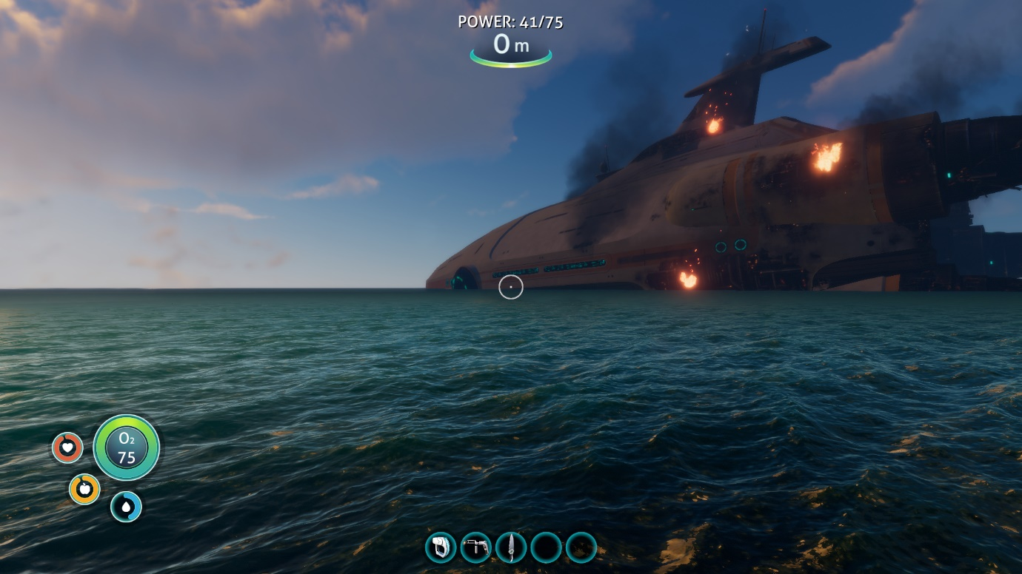
Figure 1: Subnautica Open Ocean

Horror in Design
“Horror is a genre of storytelling intended to scare, shock and thrill it’s audience” (Jonathan Scott, 2025) is the definition of what the genre actually is, but using it is more left open to interpretation. People have different tolerance to horror, some are easily frightened, and some require a lot more to get a scare out of. The whole reason people enjoy/seek out horror is “to engage with our fears safely” (Monica Evans, 2024) and allow us to “rehearse for the nastier side of life” (Monica Evans, 2024) and what better medium than an interactive one like video games. To be able to give the player control of their experience can allow for more effective creation of horror due to giving the player a goal and threatening them on the way to their goal.

Dread in Other Mediums
Other mediums also create a sense of dread, a classic and most used example is film. As it is less interactive than games, it requires the director to use different methods to create the same level of dread by using cinematography. One method directors like to follow is to never show the monster in full effect. Instead “the monster therefore acts as a conduit that can be replaced by numerous malicious forces that are considered dangerous by the spectators” (Matthias De Bondt, 2023). This keeps the audience guessing about what the threat could actually look like, thus creating a feeling of dread. Another method films use is shot composition. When an actor is on screen and is looking at something and the camera is framed to place the actor at the right of the screen, it creates dramatic irony for the audience as they may be aware of a threat that the character on screen isn’t and dread at the idea of them being attacked. The other way around where the actor is more to the left may create a feeling of unknown to what the character is looking at, letting directors focus on the characters face to display emotions that they want the audience to also feel at whatever they are focusing on.
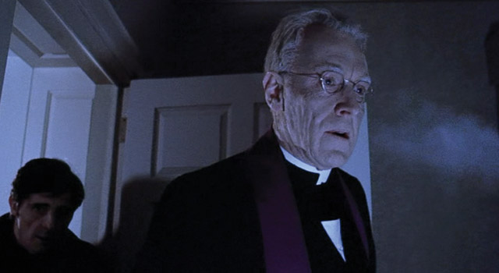
Figure 2: The Exorcist (1973) - Character on the right of screen

Figure 3: Halloween - Character on left of screen

My Project Impact
Dread in my project will combine both elements of mediums in one. Utilising film horror by making the player ask questions that won’t be answered and left up to interpretation but also keep it engaging by rewarding the player by revealing smaller things such as pieces of lore as they progress. Not only that, but I will use 3 disparate game design philosophies that are commonly used to focus on inducing specific players emotions; “fear and anxiety, vulnerability of being alone in a hostile environment and the heavy responsibility of making difficult decisions.” (Monica Evans, 2024)

Approach

The Gameplay
For the gameplay itself, the player will be following through a short story comprised mainly through dialogue and internal dialogue. As they progress through the story, they will be given options to change the outcome of a dialogue. For now, these changes will be minute and not game impacting due to the scope of the project. The other part of the gameplay will involve a basic and easy to understand puzzle section. This is to not relegate my story to a basic walking simulator and gives the player something to do to feel that they are advancing through the story. Not only that but immersing the player by having them do actions in game will further enhance the feeling of dread as they can never be too sure what’s waiting for them after completing a short puzzle. Examples of a puzzle could be they discover a key that unlocks a chest which causes a crew member to appear behind them, giving them a small fright. Below, I have outlined the important game design components that my game will follow, the core loop of the gameplay, the 3 Design pillars and finally the overall flow of the game itself.
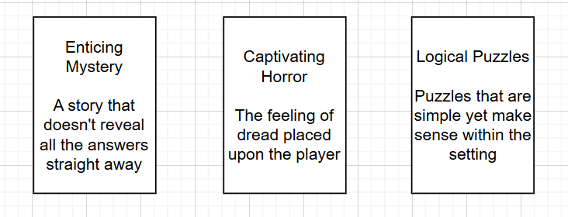
Figure 4: My Game Design Pillars
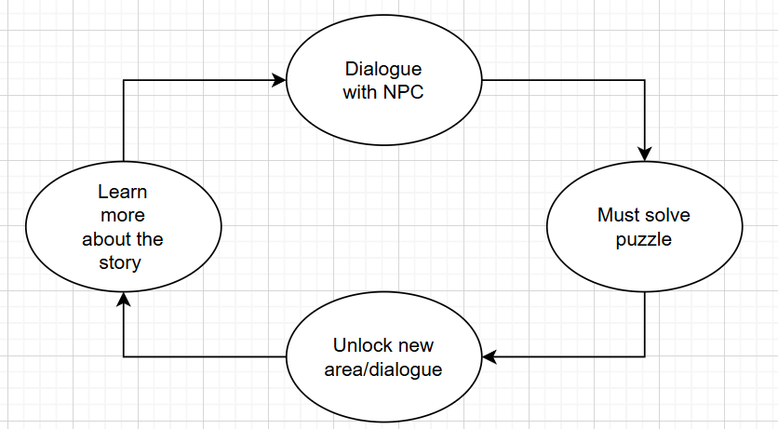
Figure 5: Core Loop
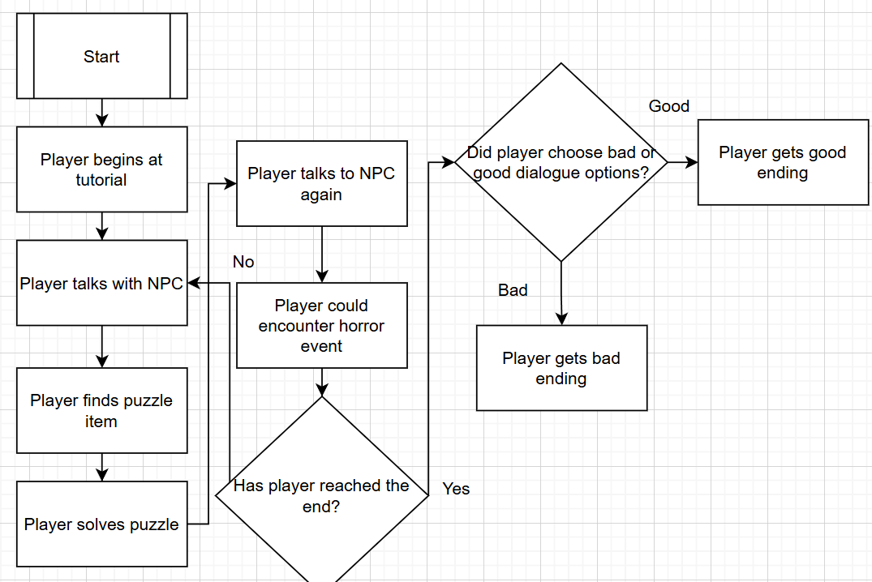
Figure 6: Flowchart of Gameplay

The Player
The player itself will be given the ability to walk and only jump but a short distance. This is to ensure that the player can make it out of a situation where they might get stuck but not for actual gameplay purposes. I feel that limiting actions the player can take during gameplay can also increase the feeling of dread due to not having full control of what you can do. There will be no need to have a run button as the player is on a small ship. They will be allowed to interact with certain objects that will be vital to the gameplay as it will advance the story if done correctly. Most of the time the player will be interacting with the NPCs to get pieces of dialogue and story bits to immerse themselves in the world a bit more. I will limit how often the player can talk to them to make them feel more alone to further hone in on the emptiness of the sea and create that psychological horror of wondering if what they encountered is real or not. Referencing the Quantic Foundry's User Profile model, I believe the profile of the player that fits best is one who plays for Immersion. These types of players enjoy a good story that they can immerse themselves in which is part of my investigation into creating that effective feeling of dread.

The Level
There will be two levels. One will be the tutorial area and then the main area. The tutorial area will serve as just that, a tutorial, but also is a narrative piece as the area will be in stark contrast to the main ship area as you play. Being on an island at dawn with houses makes the player feel somewhat safe that they are in the presence of some civilisation, which will change as soon as they depart. The main ship area will be small to create the feeling of claustrophobia alongside the feeling of loneliness while being out at sea. Limiting the player’s view by making it set at night will also help with the dread feeling as the dark/fog is a common technique to make people scared of the unknown. Throughout the story, the player will be immersed by the sounds they hear, no music will be played but small things like the creaking of floorboards and loud sudden sounds will keep the player feeling on edge, never knowing what to expect next. The finale will be the ship area but set during the morning to give the player a sense of relief that they have made it through the horror but they still won’t be able to let their guard down as I will continue making them guess with visual cues and sounds.

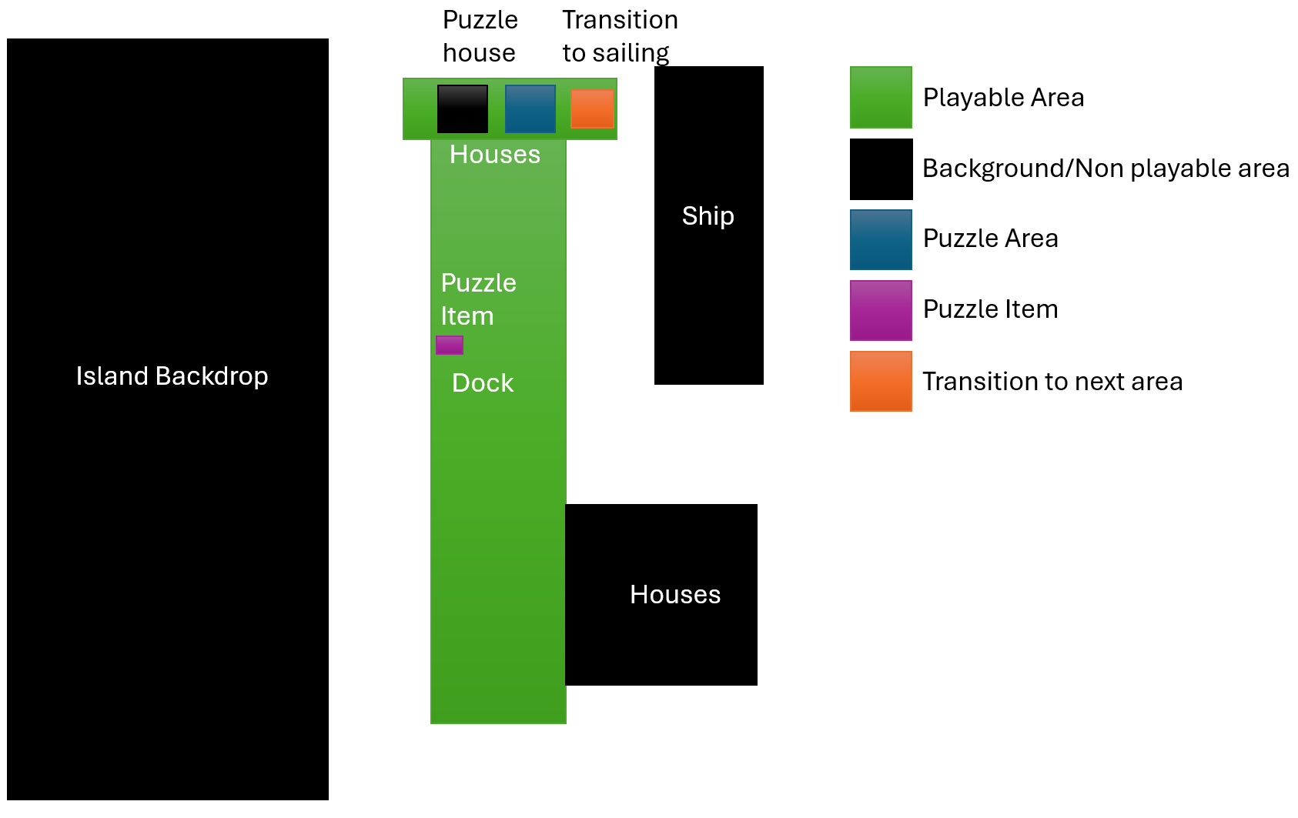
Figure 7: Tutorial Level Layout
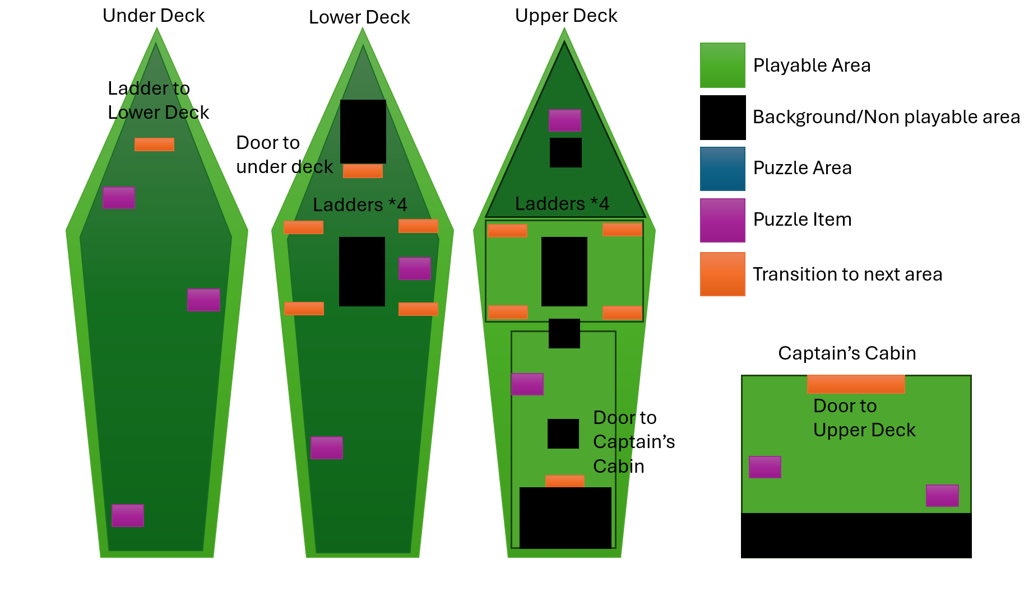
Figure 8: Main Ship Level Layout

Artefact Outcomes

Artefact Strengths
I feel that overall my artefact has quite a good amount of strengths. I managed to create the sense of dread by using sound cues and visual events. Making the player feel on edge when they see something through their spyglass, then seeing it again which causes it to disappear, tying the player to the character by also thinking they have seen something which may not be real. The sound cues I had used also helps reinforce this as they play through investigating where sounds come from and realising they are following red herrings. Some more strengths I feel that the artefact has is the overall gameplay and plot. A simple puzzle game mixed with a narrative walking game was the perfect setting to try and immerse the player when building up to that feeling of dread as they play. Using a sea theme follows Subnautica in its footsteps with themes of thalassophobia and the feeling of being alone.

Artefact Weaknesses
I think some of the weaknesses the artefact provides is from the dialogue and pacing. I had to create the story with the idea that it could potentially continue if I wanted to, however as I havent had much experience with correctly pacing the story, it may feel rushed when playing. Parts like the ending don’t leave much room for a continuation and reaching an ending like this quite quickly may make players feel too rushed into the plot, potentially ruining the build up of dread I inteneded to create for the player to experience. Not only that, but I feel that the dialogue may feel a bit unnatural, I tried to combat this by limiting the amount of times you speak to other NPCs, but even still it may throw some people out of immersion.

Challenges Faced
Some of the challenges I had faced during development were involving creating the narrative as well as creating an effective feeling of dread. As I am not usually adept at creating a narrative from scratch, I found it difficult to precisely imagine how to put the pieces together when creating my artefact. Dialogue writing is a weakness of mine that I intended to work on throughout this project and I feel that I had created a more engaging narrative than I created in my previous projects. Thinking about how people naturally talk and translating it to a video game medium was difficult but I think I managed to get a hold of it in the end, not to the degree I had hoped but well enough for the artefact. The creation of dread was also a challenge due to it being so difficult to create in the first place. This is due to the fact that as the designer myself, after replaying the events for testing, the horror gets less effective on a personal side. However, I think with the length of the artefact and time given I think I at least created a good effect of dread on the player.

Future Development
For future development, I think I would focus on improving the overall dialogue between the player and NPCs by reading up on more examples of how other games have done it. Even using other mediums such as film screenplays may be a good guide on improving how the characters speak to each other more naturally. I would also add more substance to the main gameplay, perhaps adding in more challenging puzzles and more interactivity as to try to further immerse the player into the world of my artefact. I would also like to brush up on the overall pacing and extend certain sections of the game so that they further enhance the build up of dread I’m trying to create.

Conclusion and Reflection

Research
I feel my research into my investigation went well, I had found plenty of sources this time around and used them more in my discoveries. More articles I have found were made more recently had helped as they were more up to date. Not only that, but I found it effective to research other mediums into my investigation to give a wider insight into my artefact and how I could improve my overall design. I can admit that I would’ve liked to have found more closer examples to my artefact that I could’ve talked about so that there could be a comparison to how someone else had attempted to investigate a similar topic to me.

Development
My development process went really well this time round, I had improved upon my previous time keeping issues as well as my organisation skills. I had started with development at an appropriate time and worked hard on creating a full experience that the player can enjoy from start to finish. I feel that with this project, I had learnt from all my past experiences and mistakes and created what I believe to be my best project yet. I also enjoy that I was able to have the game look a specific style that I could easily replicate with made assets that I used throughout development, making it easier for me to work with. I will admit there are a few things that I would like to have adjusted had I started a bit earlier such as a larger level for the player to spend some time in as well as giving the player more to do when playing instead of relegating the puzzles in the game to a simple click and use on certain objects.

Investigation
The conclusion of my investigation I believe is that effectively creating dread in a video game medium is possible and has been successful in other projects as well as mine. Being able to immerse a player while they are playing directly in the world helps with this as they are actively controlling the events as they are happening be it with a simple button push to go to the next dialogue or having to escape from a monster with well timed jumps. In my project specifically, letting the player control the character as they go around the ship and solve puzzles makes that build up of dread more personal as it links the player to the characters emotions while playing. Having in game events be hallucinatory is part of the story but makes you think twice, did I really hear that noise? Did I see that in the distance?

Self-Reflection and Future
If I was to continue this project in the future, I would definitely create a more episodic style of adventure, perhaps exploring the captains psyche and the further he delves into insanity. Or perhaps I would explore the perspectives of the other characters experiences at sea and how they would all react to similar events. I would also want to brush up on my dialogue writing skills and learn more how I can make characters speak to each other in universe more organically. I would do this by researching more horror narratives and view how they make characters speak to each other and take inspiration from them. Overall, I feel that this project may have been my best work yet, I had put a lot of effort in the details of the artefact and created a start and finish that I am proud of. Despite the minor hiccups I had encountered while creating the artefact, I feel I have prevailed through and created something worth playing.

References
Monica Evans. (2024) ‘Too Afraid to Go Deeper: Creating Pervasive Dread Through Blended Design Structures in Subnautica and Subnautica: Below Zero’, Game Studies, December. Available at: https://gamestudies.org/2404/articles/evans (Accessed: 29 April 2025).
GameDev.net (2018) ‘Creating Dread in Horror Games’, GameDev.net Blog, 10 February. Available at: https://www.gamedev.net/blogs/entry/2266481-creating-dread-in-horror-games/ (Accessed: 29 April 2025).
Matthias De Bondt. (2023) ‘The Emotion of Dread in Cinematic Horror’, ResearchGate, 9 March. Available at: https://www.researchgate.net/publication/369093199_The_Emotion_of_Dread_in_Cinematic_Horror (Accessed: 29 April 2025).
Jonathan Scott (2025) ‘What is Horror — Definition and Examples’, StudioBinder Blog, 4 February. Available at: https://www.studiobinder.com/blog/what-is-horror-definition/ (Accessed: 29 April 2025).
Unknown Worlds (2018) Subnautica, 23 January. Available at: https://unknownworlds.com/en/games (Accessed: 29 April 2025).
Quantic Foundry (2015) ‘Gamer Motivation Model’, Quantic Foundry. Available at: https://quanticfoundry.com (Accessed: 29 April 2025).
Jason Hellerman (2023) ‘13 Horror Camera Angles That Create Suspense’, No Film School, 31 October. Available at: https://nofilmschool.com/horror-camera-angles (Accessed: 29 April 2025).
Lyric Burt (2023) ‘Shadows and Shivers: The Art of Cinematography in Horror Films’, Nevada Storytellers. Available at: https://nvstorytellers.org/2024/09/23/shadows-and-shivers-the-art-of-cinematography-in-horror-films/ (Accessed: 29 April 2025).
Phillippa Warr. (2018) ‘Subnautica review’, PC Gamer, 29 January. Available at: https://www.pcgamer.com/subnautica-review/ (Accessed: 29 April 2025).

External Resources

Sounds
TheBuilder15, 2022. Footsteps with Floor Creak. [online] Available at: https://pixabay.com/sound-effects/footsteps-with-floor-creak-81239/ [Accessed 29 Apr. 2025].
Sonniss, 2024. GDC Audio Bundle. [online] Available at: https://gdc.sonniss.com/ [Accessed 29 Apr. 2025].
Juanjo_sound, 2024. Dark Ambient Music - Into Insanity Vol. 2. [online] Available at: https://www.fab.com/listings/5c5ecdb0-fb84-455d-8ca0-3eab828a9b07 [Accessed 29 Apr. 2025].
ShashiRaj Productions, 2024, Deadly Creatures Sound Effects Pack 1[online] Available at: https://www.fab.com/listings/9d4c3cc6-1720-447a-981c-ba1349cf2810 [Accessed 29 Apr. 2025].
PlaceHolder Inc, 2024. 50 Free Game Sounds Pack[online] Available at: https://www.fab.com/listings/b8cc7270-5e0c-4ef7-a277-6a1d4b69358d [Accessed 29 Apr. 2025].
Gregor Quendel, 2025. Free Thunder Sounds [online] Available at: https://www.fab.com/listings/c832a656-f75c-45fc-bdb1-8fb702a7ba90 [Accessed 29 Apr. 2025].
Danes_dysfunction, 2025. Horror Ambient Sound Effects Pack_01[online] Available at: https://www.fab.com/listings/85cf0752-628a-4ed2-b68d-0234cc7ad8c2 [Accessed 29 Apr. 2025].
U_smr75jauso, 2024 Indian Ocean Sound from Zanzibar at Sunrise. [online] Available at: https://pixabay.com/sound-effects/indian-ocean-sound-from-zanzibar-at-sunrise-190466/ [Accessed 29 Apr. 2025].
VoiceBosch, 2024. Creaking Wood. [online] Available at: https://pixabay.com/sound-effects/creaking-wood-199971/ [Accessed 29 Apr. 2025].
Mrickey13, 2021 Item Equip. [online] Available at: https://pixabay.com/sound-effects/item-equip-6904/ [Accessed 29 Apr. 2025].
crinkem, 2022. Metallic Latch Release. [online] Available at: https://pixabay.com/sound-effects/metallic-latch-release-43678/ [Accessed 29 Apr. 2025].
ElGeorgia, 2022 Steps on Wooden Stairs. [online] Available at: https://pixabay.com/sound-effects/steps-on-wooden-stairs-90107/ [Accessed 29 Apr. 2025].
DarkWorld Audio, 2021 Sound Effects Survival I. [online] itch.io. Available at: https://darkworldaudio.itch.io/sound-effects-survival-i [Accessed 29 Apr. 2025].
borralbi, 2022. Sailboat Cockpit at 12kn Wind Speed. [online] Available at: https://pixabay.com/sound-effects/sailboat-cockpit-at-12kn-wind-speed-17465/ [Accessed 29 Apr. 2025].
FreeSFX, n.d. Creaking Sounds. [online] Available at: https://www.freesfx.co.uk/sfx/creaking [Accessed 29 Apr. 2025].
FreeSFX, n.d. Drop Sound Effects. [online] Available at: https://www.freesfx.co.uk/sfx/drop [Accessed 29 Apr. 2025].
FreeSFX, n.d. Woman Scream. [online] Available at: https://www.freesfx.co.uk/sfx/woman-scream [Accessed 29 Apr. 2025].
Freesound Community, 2022. 042022 Woman Humming. [online] Available at: https://pixabay.com/sound-effects/042022-woman-humming-75962/ [Accessed 29 Apr. 2025].
SoundReality, 2022 Door Slam. [online] Available at: https://pixabay.com/sound-effects/door-slam-172171/ [Accessed 29 Apr. 2025].

Assets
ARU, n.d. University Shared Folder [online] Available at: https://myaru.sharepoint.com/sites/OU-100228/Shared%20Documents/Forms/AllItems.aspx?id=%2Fsites%2FOU-100228%2FShared%20Documents%2FStudent%20Shared%2FExternal%20Assets&p=true&ga=1
[Accessed 29 Apr. 2025].
PONETI, 2021. Classic RPG GUI. [online] Available at: https://assetstore.unity.com/packages/2d/gui/classic-rpg-gui-160253#content [Accessed 29 Apr. 2025].
noyou, 2020. Headwear. [online] Available at: https://sketchfab.com/3d-models/headwear-fe308b9250974ede990407d15b733f5e [Accessed 29 Apr. 2025].
Elbolilloduro, 2022. Houses on the water. [online] Available at: https://itch.io/queue/c/4155135/psx-game-assets?game_id=1383605 [Accessed 29 Apr. 2025].
NotYetGames, n.d. DlgSystem. [online] GitHub. Available at: https://github.com/NotYetGames/DlgSystem [Accessed 29 Apr. 2025].
PorkBellyGames, 2023. Retro Wilderness Assets. [online] itch.io. Available at: https://porkbellygames.itch.io/retro-wilderness-assets [Accessed 29 Apr. 2025].
TIG, 2023. Pirate Ship (Rigged). [online] Available at: https://sketchfab.com/3d-models/pirate-ship-rigged-f78e4e29b78c422b8db540459882e601 [Accessed 29 Apr. 2025].
Philip_Erd, 2022. LoFi3D Pirate Scenery. [online] Available at: https://itch.io/queue/c/4155135/psx-game-assets?game_id=1758554 [Accessed 29 Apr. 2025].
PROTOFACTOR INC, 2016. Kraken. [online] Available at: https://www.fab.com/listings/6c03486a-a6fe-4c81-b699-f0c533ebf87d [Accessed 29 Apr. 2025].
Niko-Gillsky, 2024. PSX FPS Hands. [online] itch.io. Available at: https://niko-gillsky.itch.io/psx-fps-hands [Accessed 29 Apr. 2025].
Anna Vidal, 2018. Low Poly Pirate Spyglass (2 Parts). [online] Available at: https://sketchfab.com/3d-models/low-poly-pirate-spyglass-2-parts-9c597a26d2e243d4bb35f380746a464f [Accessed 29 Apr. 2025].
Antonia Wooff, 2023. Stylized Fantasy Key. [online] Available at: https://sketchfab.com/3d-models/stylized-fantasy-key-b5431c53a2ed48db9fde3ebfc59cd56a#download [Accessed 29 Apr. 2025].
M5VFX, 2018. M5 VFX Vol2. Fire and Flames(Niagara) [online] Available at: https://www.fab.com/listings/c5b0270a-a295-4644-a4be-42cb1e56a197 [Accessed 29 Apr. 2025].
Mixamo, n.d. Mixamo Animation Library. [online] Available at: https://www.mixamo.com/#/ [Accessed 29 Apr. 2025].
Luos_83, 2015. Material Function - World Aligned Texture Normal with Offset/Rotation. [online] Available at: https://forums.unrealengine.com/t/material-function-world-aligned-texture-normal-with-offset-rotation/45979/2 [Accessed 29 Apr. 2025].
Incg5764, 2022. Letter. [online] Available at: https://sketchfab.com/3d-models/letter-303b287819a84f7496bd92f5d69710c7#download [Accessed 29 Apr. 2025].
KloWorks, 2016. Rust Key. [online] Available at: https://sketchfab.com/3d-models/rust-key-dbba2fadae1b48adb03c62123a4babcf#download [Accessed 29 Apr. 2025].
Chilly-Durango, 2021. Medieval Building Parts. [online] itch.io. Available at: https://chilly-durango.itch.io/medieval-building-parts [Accessed 29 Apr. 2025].
Rivaldragon, 2019. Prison Cell Door. [online] Available at: https://sketchfab.com/3d-models/prison-cell-door-f8148fab4dc44903b9644170edf0e58c [Accessed 29 Apr. 2025].

Images
Ahkam, n.d. Seamless Rope Textures PNG Transparent Background [online] Available at: https://www.freeiconspng.com/img/45176 [Accessed 29 Apr. 2025].
Ramirez Guerra, M., 2020. The Foundation of Women’s Liberation in Weimar (1770s–1806). [online] Women’s History Network. Available at: https://womenshistorynetwork.org/the-foundation-of-womens-liberation-in-weimar-1770s-1806-by-dr-marystella-ramirez-guerra/ [Accessed 29 Apr. 2025].
Vecteezy, n.d. Dramatic Thunder Lightning Strikes Against a Transparent Background. [online] Available at: https://www.vecteezy.com/png/57174190-dramatic-thunder-lightning-strikes-against-a-transparent-background-during-a-stormy-weather-event-thunder-lightning-transparent-background [Accessed 29 Apr. 2025].

Tutorials
Unreal University, 2023. How To Make An Options Menu - Unreal Engine 5 Tutorial [video] YouTube. Available at: https://www.youtube.com/watch?v=Ff67XtqgSxc [Accessed 29 Apr. 2025].
Shunitzo, 2024. Tutorial: Simple Inventory System – Part 2 is Here!. [online] Available at: https://forums.unrealengine.com/t/tutorial-simple-inventory-system-part-2-is-here/1316560 [Accessed 29 Apr. 2025].
Coreb Games, 2025. UE5 l Learn Sine Wave Techniques l 5-Minute Shader Tutorial l Unreal Engine 5 [video] YouTube. Available at: https://www.youtube.com/watch?v=HtStFVFGhOo [Accessed 29 Apr. 2025].
Ashty, 2022. How to make your own customizable PS1 Shader in 4 minutes (UE4/UE5). [video] YouTube. Available at: https://youtu.be/ST_JTXuGmv0?si=myfRKgd7Rs-jqh2U [Accessed 29 Apr. 2025].
Unreal University, 2025. How To Make A Volume Audio Setting Menu In Unreal Engine 5 ( With Save and Load ) [video] YouTube. Available at: https://www.youtube.com/watch?v=6wgDg-Eivf4 [Accessed 29 Apr. 2025].
Matt Aspland, 2024. How To Make The Player Look At An Object In Unreal Engine 5 (Tutorial). [video] YouTube. Available at: https://www.youtube.com/watch?v=yXohDuIT0pc [Accessed 29 Apr. 2025].
Gorka Games, 2023. How to Make the NPC's Head Look At the Player in Unreal Engine 5 [video] YouTube. Available at: https://www.youtube.com/watch?v=8skq8t_Fffk [Accessed 29 Apr. 2025].
Matt Aspland, 2021. First Person Footsteps | No Mesh Or Animations - Unreal Engine 4 Tutorial [video] YouTube. Available at: https://www.youtube.com/watch?v=I973d6ABTf4 [Accessed 29 Apr. 2025].
CodeLikeMe, n.d. Unreal Engine 5 Beginner Series Playlist. [video playlist] YouTube. Available at: https://youtube.com/playlist?list=PLNTm9yU0zou5o5puKFfNjFUeTE0wBVwOA&si=YTdnUmSdZAkDZCaN [Accessed 29 Apr. 2025].

Fonts
Typographer Mediengestaltung, n.d. Caslon Antique Font. [online] Available at: https://www.1001fonts.com/caslon-antique-font.html [Accessed 29 Apr. 2025].
28fonts, 2017. Naughty Scratch. [online] Available at: https://www.dafont.com/naughty-scratch.font [Accessed 29 Apr. 2025].
SparklyDest, 2013. Pixel Pirate. [online] Available at: https://www.dafont.com/pixel-pirate.font [Accessed 29 Apr. 2025].
RantautypeStudio, 2025. Bridget Lily. [online] Available at: https://www.dafont.com/bridget-lily.font [Accessed 29 Apr. 2025].
Letterena Studios, 2025. Ramsoneth. [online] Available at: https://www.dafont.com/ramsoneth.font [Accessed 29 Apr. 2025].

